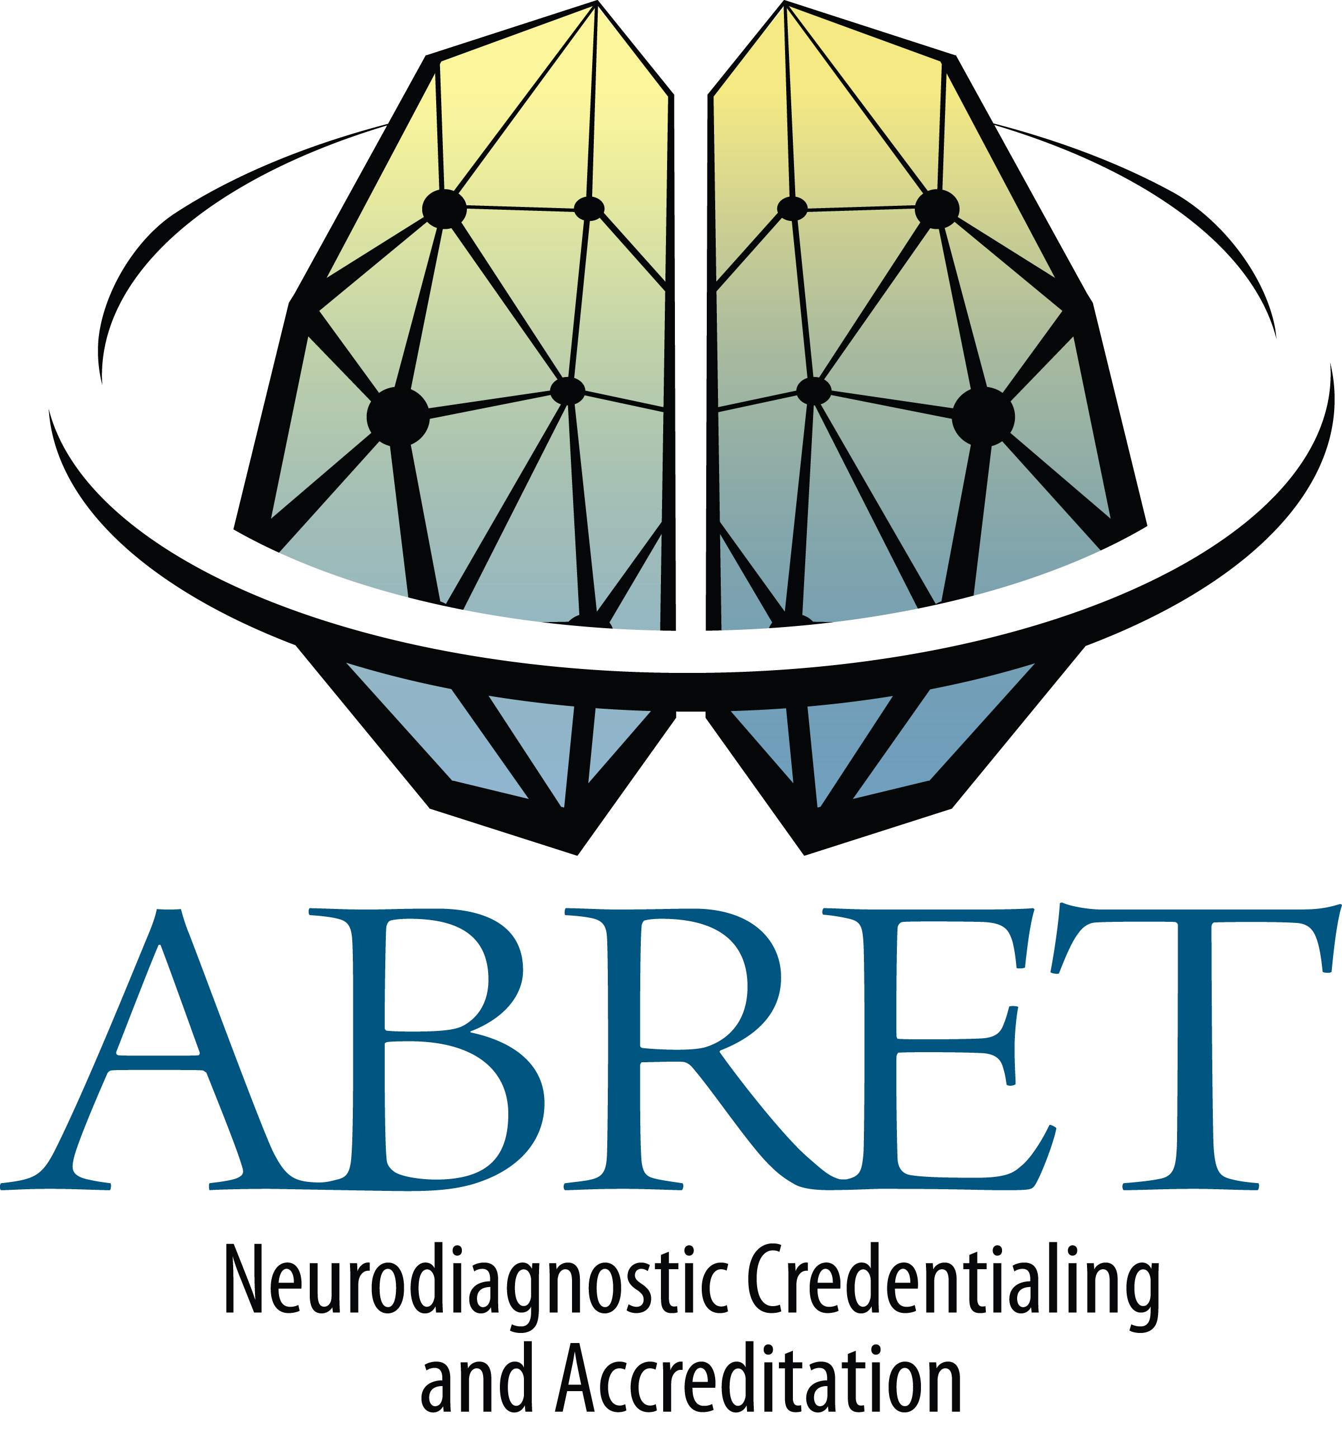

CNIM Educational Documentation Form

Name

Address:

Social Security No:

E-mail/Phone

Certificate No. | Date of Certification: | Expiration Date:

As of 2006, re-credentialing for CNIM will require documentation of continuing education, totaling a minimum of 50 hours over the five-year period following initial certification. A $100 fee is required.
- Education hours are credited on a 1:1 basis. One hour of education (contact) equals one education credit.
- CNIM-specific education would include department in-services, review courses, local, state, regional or national professional meetings, journal reviews earning ACE credits through ASET (journal reviews may count for no more than half of the required hours), covering IOM, EP, EMG, EEG, or relevant Neurology/Orthopedic topics. Any educational format where appropriate content is the focus will be accepted. Persons presenting an IOM lecture may count the lecture hour(s) as continuing education, as long as this activity is not related to employment as an educator.
- When renewing more than one credential, continuing education may overlap if obtained within the appropriate time frame, but must be documented appropriately on the accepted form.
- Verification of participation in continuing education may be required by ABRET. Records should be maintained by the technologist.
- Technologists should notify ABRET of any address or name change.
- Paperwork and fee should be submitted prior to the expiration date, in the year the certification expires.
- When a technologist’s credential expires, recredentialing is required to reclaim certification.
- When a technologist fails to renew his/her credential, they are not eligible to legally claim certification.
Incomplete forms will not be accepted. Proof of attendance does not need to accompany this form.
EDUCATIONAL DOCUMENTATION FORM

Name: ________ CNIM Number:

COURSE NAME | DATE(S) | LOCATION | TOPIC | SPONSOR | EDUCATION CREDITS ACQUIRED (1 hour = 1 credit)
TOTAL HOURS

I understand that providing false information on this form may result in suspension or revocation of my certification.

Applicant's Signature: Date:

Return this form to the ABRET Executive Office, 2908 Greenbriar Dr., Suite A, Springfield, IL 62704.
Incomplete forms will be returned.
Approximately 10% of forms will be randomly audited for proof of attendance and appropriate content

