CLTM® DOCUMENTATION FORM
Fill out the form to log your required Long Term Cases (50), have supervisor sign, and upload to ABRET Credential Manager. ABRET will accept up to three LTM cases per day. A patient may only be counted once during each admission. The CLTM eligibility will include patient care time, scanning of studies, set-up/checking electrodes; mapping and writing reports. No more than 10% of cases submitted (5) may be ambulatory recordings. Cases must have been monitored within the last 5 years, with 10% (5) within the last 12 months.

NAME of TECHNOLOGIST:

NO | Date of Recording | Type of Recording/ ICU/EMU/AMB | Reading Physician | Indications for recording | Length of Recording/ min of 12 hours | Tasks Performed

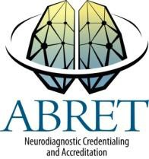
I certify that the information provided is true and accurate. Submit completed form with your application.
Random auditing will be conducted by ABRET.
***All form pages must be signed***

*Signature of Medical Director or Supervisor Date page of

Print Medical Director/Supervisor Name Phone # Email

*Supervisor is expected to be in authority over candidate and able to verify submitted LTMs
8/18

